**mv command:-**

mv command is used to move the file from one location to other location.

Initially, before executing mv command, there are three files in **“linux”** folder under desktop. 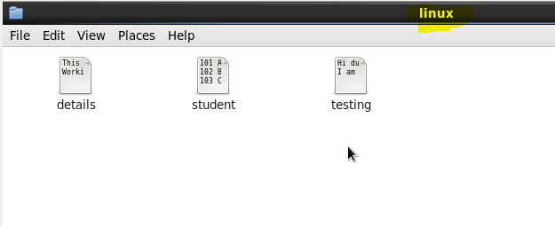

Initially there are no files in **“Student”** folder.

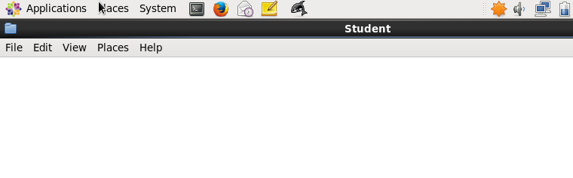

Now execute the mv command that is shown below.

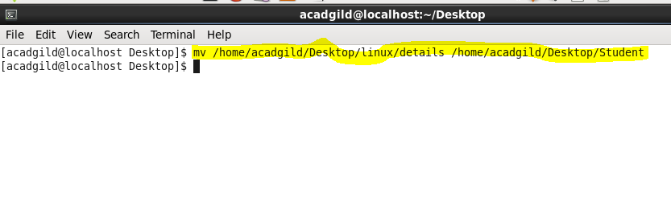

After executing, you can see the movement of file named details from **linux** folder to **Student** folder in the following two screenshots.

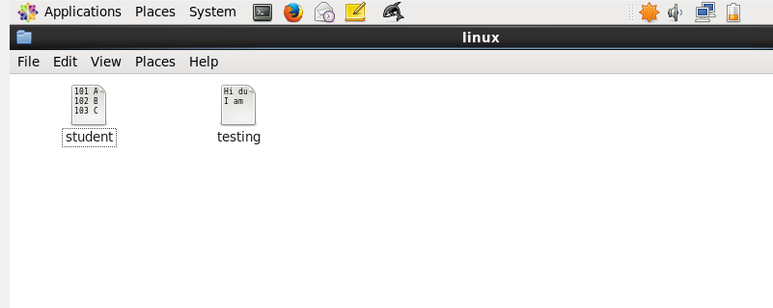

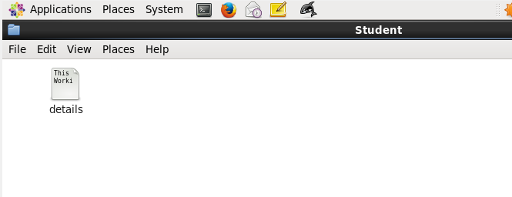

Using **mv command**, we can also **rename** the files.

For example, if you move the files in same location, then that file will get renamed.

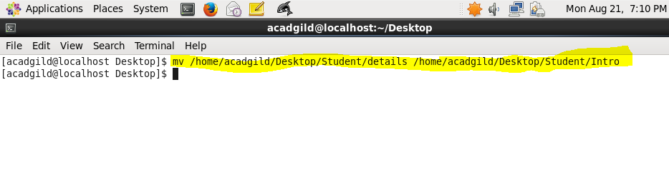After executing the above highlighted command, the file named **“details”** will be renamed to **“Intro”** under Student folder in Desktop.

